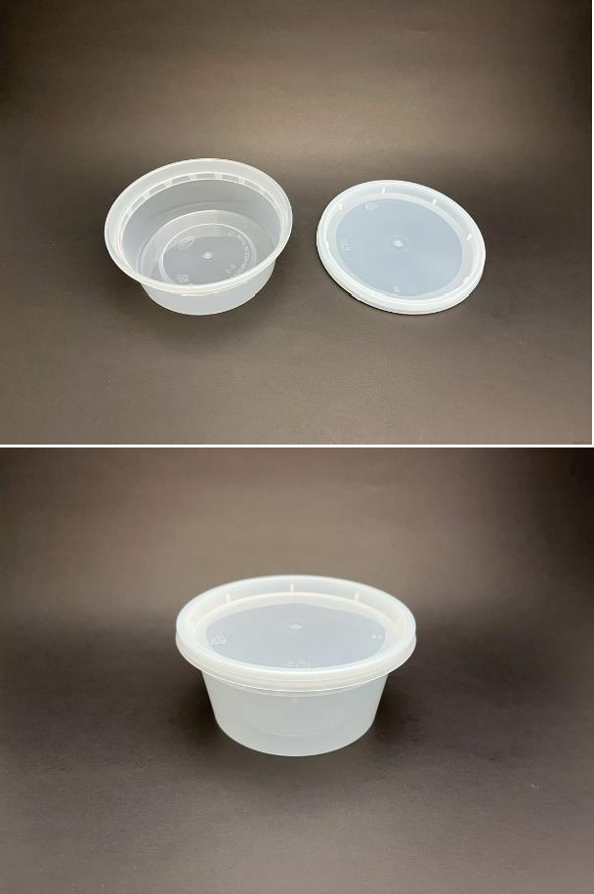  IMAGE | ITEM DESCRIPTION |  | PRICE  * S U B J E C T T O T A X E S
 | S-8 | Low Density 8oz Microwavable  Deli (240/case) with lids |  | $23.50
 | S-12| Low Density 12 oz Microwavable  Deli (240/case) with lids |  | $25.5
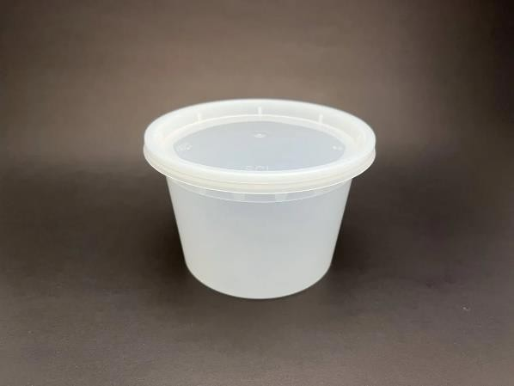 | S-16| Low Density 16 oz Microwavable  Deli (240/case) with lids |  | $28.5

 | 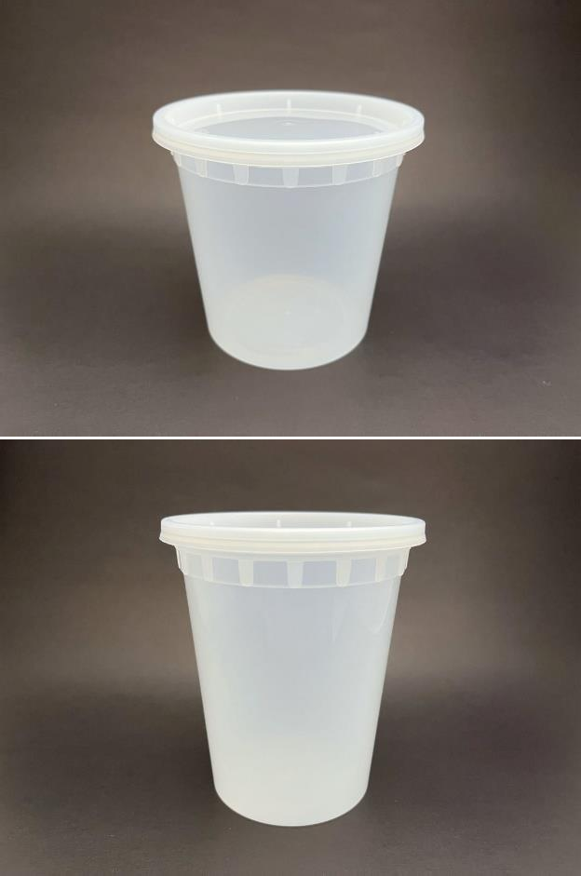  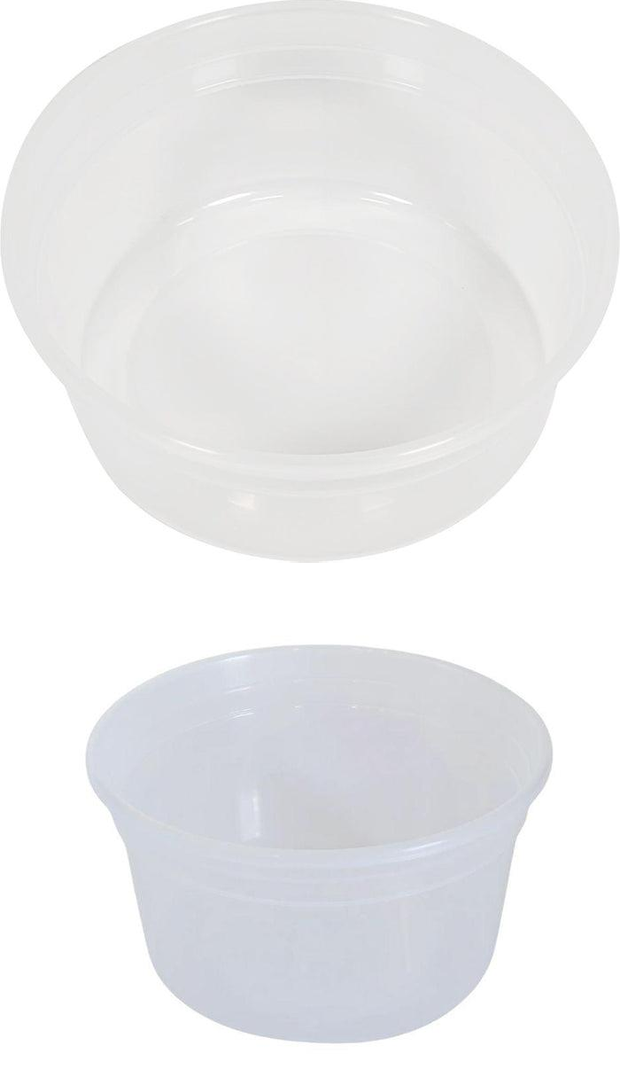  S-24| Low Density 24 oz Microwavable  Deli (240/case) with lids |  | $36.5
 | S-32| Low Density 32 oz Microwavable  Deli (240/case) with lids |  | $42.5
 | H2808| Heavy Duty 8oz Microwavable  Deli (500/case) without lids |  | $91.50
 | H2812| Heavy Duty 12oz Microwavable  Deli (500/case) without lids |  | $97.85

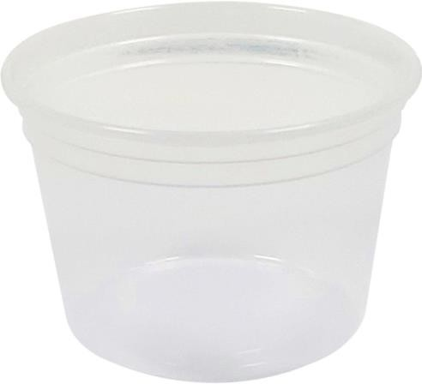 | H2816| Heavy Duty 16oz Microwavable  Deli (500/case) without lids |  | $107.20
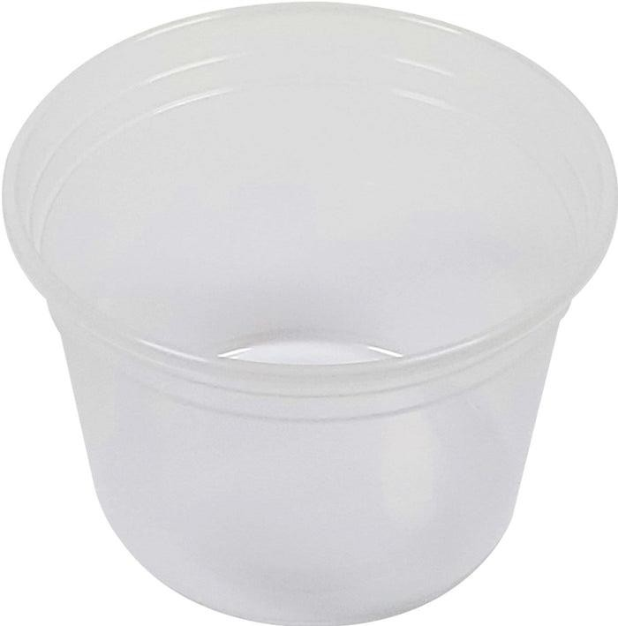 | H2820| Heavy Duty 20oz Microwavable  Deli (500/case) without lids |  | $122.43
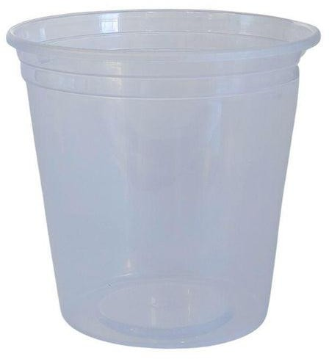 | H2824| Heavy Duty 24oz Microwavable  Deli (500/case) without lids |  | $127.70

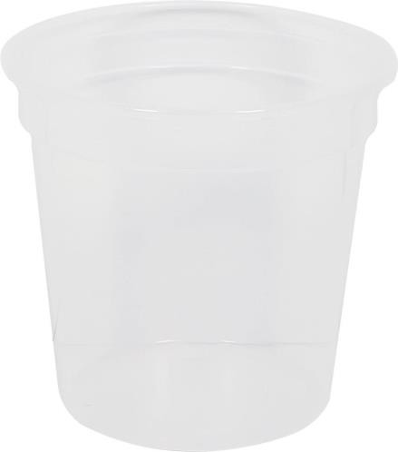 | H2832| Heavy Duty 32oz Microwavable  Deli (500/case) without lids |  | $158.34
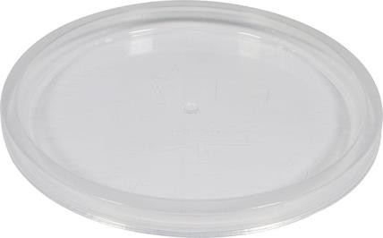 | H8| 4.5’’ Deli container lid  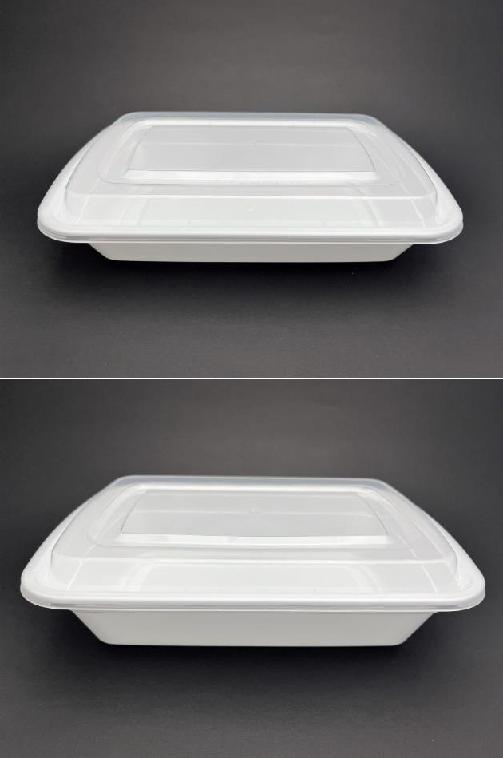  Deli (500/case) without lids |  | $74.30
 | T-28| 280z Microwavable Rectangle  (150/case) with lids |  | $36.65
 | T-38| 28oz Microwavable Rectangle  (150/case) with lids |  | $36.65

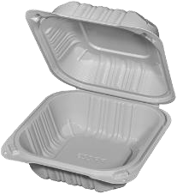 | PP-008| 6x6x3’’  Microwavable  (250/case) |  | $25.99
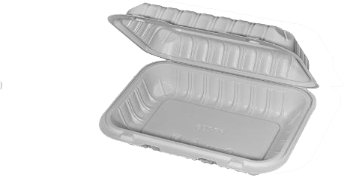 | PP-018| 9x6x3’’  Microwavable  (250/case) |  | $25.99
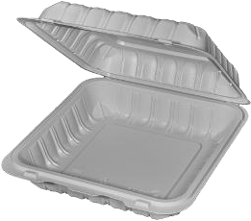 | PP-071| 7x7x3’’  Microwavable  (250/case) |  | $26.99

